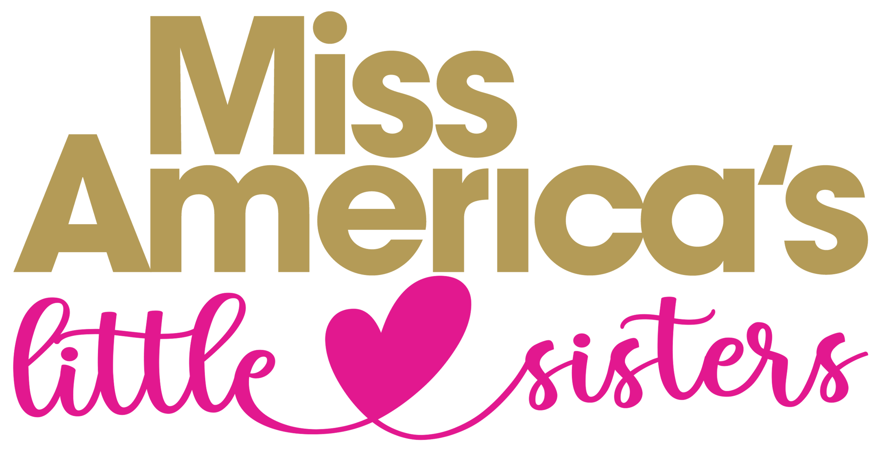
Lone Star Handbook
2023 – 2024

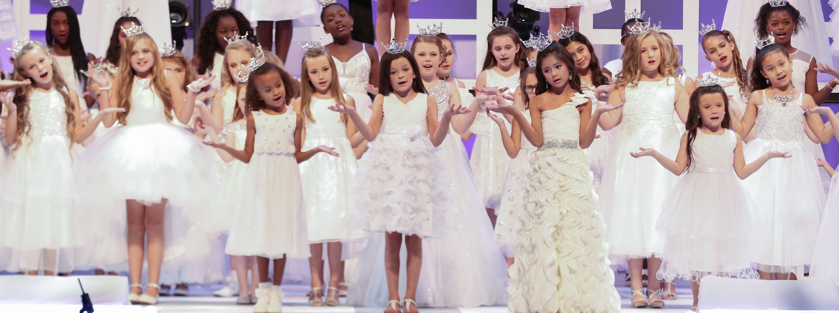
Got questions?

Since 2004 well over a thousand young girls have worn a Lone Star crown (formerly Lone Star Princess) on the Miss Texas and Miss Texas’ Teen stage. This Handbook will help you as you prepare for this exciting week.

Miss Texas Headquarters Hotel
Renaissance Dallas Richardson Hotel
900 E. Lookout Drive Richardson, Texas 75082
(make sure you book from our link so you will get a special rate)

If you stay at our Miss Texas Headquarters Hotel you will be in the center of the action and just an elevator ride away to the events. Parking is free for hotel guests. The host hotel fills up every year, so book early! The link will be on the Miss Texas Competition Week tab on the website.

CREDENTIALS
During the week there will be times when it is mandatory to wear a security badge. This is a nice keepsake and will have your identification on it. Security is essential and these are required in order to attend open rehearsals and Visitations after each Miss prelim, as well as to pick up your princess after rehearsals and other activities. The advanced purchase price for Star parent(s) badges is $15 and must be ordered no later than June 1. Competition Week they will be $25. Badges can be purchased at THIS LINK (2024 link will be posted soon).
COMMUNICATION – EMAILS, STAR PORTAL, REMIND APP, FACEBOOK PAGE
EMAILS:
You will receive emails from the Lone Star Chair (lonestar@misstexas.org) communicating announcements or instructions. Make sure the email address we have for you is one you check regularly, and on the weekend (not a work email address). Expect to receive emails up until the day before Competition Week.

PRINCESS PAGE:
The Star Page is on the Miss Texas website (www.misstexas.org) on the ABOUT page and can be found under the Lone Star tab. Materials, manuals, and other documents specific to Stars will be located here. Rather than searching through emails to refer to information, everything we send will be on this page.

REMIND MESSAGE APP
A group communication tool, we will use this during Competition Week to get info and last-minute changes to you immediately on your smart phone. More details later.

FACEBOOK PAGE:
Miss Texas Pageant Lone Star Program just for Lone Stars.

CROWN CENTRAL INFORMATION DESK
Crown Central is located in the lobby of the Renaissance Hotel Conference Center. Helpful information will be available.
Hours of Operation during pageant week:
Sunday thru Wednesday – 9am – 5pm
Thursday – 9am – 2pm
Friday – 8:30am-9:30am and then Noon – 5pm
Saturday - 9:00am – Noon (pick-ups only)

DRESS REQUIREMENTS

Rehearsals
- Casual warm-ups, jeans, shorts, workout wear, etc.
- Tennis shoes, sneakers, dance shoes (any color/kind). Please no flip-flops or bare feet.
- Sweater/jacket (the rehearsal hall is sometimes quite cool)

Crown & Sash
- Each crown is carefully inspected prior to packing into the crown box to ensure it contains all crystals and is free from dents or any other defects. Please handle it with care and keep it in a cushioned container when not wearing it, as they are non-returnable.
- Please do not add “bling” or embellishments of any kind.

Competition Performances Attire
- Dressy, SOLID WHITE dress (any style or type of fabric). No ivory, cream, or ecru. Try to stay away from dresses that are too full. Sashes, bows, appliqués, buttons, etc. MUST be white, silver, or clear. Sparkles/stones must be clear or silver and at a minimum (dress should be primarily white). The hem must fall between the knee and the ankle and must NOT touch the floor.
- Shoes - white, silver or clear (age appropriate). For safety concerns, the shoes should be secure when dancing, climbing stairs, etc. (no slides/slip-ons or high heels).

DVD ORDERS – JC PRODUCTIONS
JC Productions offers a set of DVDs that include all three preliminary nights and the final night, as well as additional Events that the Stars attend. They offer great packages and we highly encourage you to get your order in! Not only will you love having great memories, but this will be your only way to have photos to enjoy later, as there are NO cameras allowed in the theatre.

EISEMANN CENTER 2351 Performance Dr. Richardson, TX 75082 Ticket Office 972 744 4650
Competitions and LSP Performances will be held here, adjacent to the Headquarters Hotel.

GIFT/FLOWER ROOM (Wildflower Room)
You can leave gifts, flowers, notes, cards, etc. for their Stars and contestants in the Gift Room. They love visiting the gift room several times a week to see what awaits them. No need for expensive items; they are usually simple, token “Have a good show!” or “Have a Great Week” gifts. Plan ahead and pick up fun, inexpensive things. Lip gloss, nail polish, jewelry, snacks, candy, clothes, books, puzzles, toys, stuffed animals, Star logo merchandise from the store (above) or anything your Star likes will make their week even more special. Wrap them up or put them in a colorful gift bag each day. If you want to order flowers our official florist is McShan Florist and there will be details sent if you would like to have flowers at least one day.

- Gifts, flowers and cards, etc. must be checked in at the front table located in the Flower/Gift Room. Nothing will be accepted at the Eisemann Center. Record tags must accompany each gift and will be available just outside the Gift room.
- If you or anyone from your hometown or relatives wish to ship something for your Star to the hotel, please send to: “Lone Star name c/o Renaissance Dallas Richardson Hotel; 900 E. Lookout Drive; Richardson, Texas 75082. They will be delivered to the official Flower/Gift Room.
- The hours of operation will be posted on the doors each day. Closed during on-stage competitions.

GRAB & GO QUICK FOOD ITEMS
The hotel will have a nice selection of quick food items that are under $10 if you need something quickly, or don’t have time to leave the hotel to eat.

HOUSING: All Lone Stars, their families and friends are responsible for their own housing and meals during competition week. Hotel reservations can be made on the Miss Texas website (www.misstexas.org). The special link is posted on the Miss Texas Competition Week page. It fills up so call and reserve your room as soon as the link is up.

LOGO/MERCHANDISE STORE
The Miss Texas Logo & Merchandise Shop is located in the Gift/Flower Room (hotel Wildflower room). They have a large selection of logo merchandise available, gifts, flowers and goodies for all contestants, Stars and fans. There will also be photo buttons and photo note cards (of your princess!) and personalized note pads available for purchase, which makes a fun, easy gift that the Stars love. Prices are very reasonable.

PARKING
All hotel guests receive FREE parking all week! We highly encourage everyone to stay at the host hotel because you’ll have the benefits of being in the center of the action, shopping with our vendors, being on hand for events during the day, dropping off and picking up your Star every day and having the convenience of dropping off gifts at the Gift/Flower Room each day. A huge benefit is that the hotel picks up hotel guests’ parking fees in the Eisemann Center garage, which can get pricey.

If you are NOT a hotel guest - the hotel will validate your parking ticket when you come for the day for Miss Texas events, however you will be responsible for paid parking in the Eisemann Center garage for each show.

PHOTOGRAPHY – BLUDOOR STUDIOS
Our Photographer is bludoor Studios who will offer a digital photo package and will include photos from on stage competition, backstage, and candid shots throughout the week. These will be treasured memories. Additional order forms will be available at Crown Central. Remember, ONLY our official photographer will be allowed to take competition, performance, and official photos so these will be your ONLY mementos.

NOTE: There is no photography or video allowed in the theatre. This includes cell phones and tablets. The light is very distracting and blocks the view of people behind you. Those bringing a camera into the theatre will not be allowed in. Ushers will approach guests who are taking pictures or video.

PROGRAM BOOKS
The 2024 program books will be available for sale with Transcript Press in the Miss Texas Logo & Merchandise Shop.

REHEARSALS
Rehearsals are critical. Stars have two production numbers that they will perform multiple times. On-stage/Production/Tech rehearsals are mandatory. Plan for your Star to attend all rehearsals, preliminaries and both final night pageants. Bring a sweatshirt or sweater because the temperature in the Eisemann theatre can be chilly. See Dress Requirements for details on wardrobe.

TICKETS
Show tickets - All individual and season tickets can be purchased through the Eisemann Center website at www.eisemanncenter.com. We recommend that your family and friends purchase Season Tickets (tickets for all 7 shows), because Single tickets are more expensive. You will receive one complimentary ticket per show for each Star.

VISIONARY AWARDS BRUNCH – Sunday, June 19th at 11am
This launches Competition Week and is your first “appearance” as a Star if you choose to attend! This is a ticketed event. It is not mandatory, but we would love our Stars to come!

GALA EVENT – Friday, June 24th at 7pm – more information coming but Stars love this! Music, dancing, etc. and fun for all!

VENDORS
There will be several vendors set up with their merchandise for everyone to shop and enjoy.

Lone Star
MEDICAL EMERGENCY CONTACT FORM

Note: This information will be used to assist in treating your child should any problems arise. For minor illness, we will
assist you in obtaining medication from your family physician. In case of an emergency, we will have a physician for you.

FRONT & BACK copies of the insurance card are required for submission

Local Title:
Princess’ Full Name:
Current Address:
City: |  | State: |  |  | Zip:
Mother’s/Legal Guardian’s Name:
Home Address:
City: |  | State: |  |  | Zip:
Home Phone: | Work Phone: |  |  | Cell Phone:
Father’s/Legal Guardian’s Name:
Home Address:
City: |  | State: |  |  | Zip:
Home Phone: | Work Phone: |  |  | Cell Phone:
Family Physician:
Office Phone: |  |  | Home Phone or Pager:
Does the contestant have any allergies or medical problems that we need to be aware of?
Yes No
If yes, please explain.
Name of Medical Insurance Company:
Insurance Company Phone Number:
If you do not have insurance coverage, please acknowledge No Insurance Coverage in field above.
Medical Insurance Policy Number: Attach a copy of your Insurance Card (front and back).
At what hotel will parent(s)/guardian(s) be staying during pageant week camp?

In the event I cannot be reached, I, the undersigned parent/guardian, give permission to the Miss Texas Organization volunteers and/or staff to seek any medical attention for my Star:
________________________________
Signature of parent/legal guardian

Lone Star & Miss Texas Organization

STATEMENT OF UNDERSTANDING & AGREEMENT TO TERMS

As the parent(s) of ___ ____ , I/we are hereby submitting her application for approval. We agree to conduct ourselves at all times in a professional manner as to not embarrass our daughter or the Miss Texas Scholarship Organization, Inc. We will ensure that our daughter will conduct herself in the proper manner at all times.

HOLD HARMLESS AGREEMENT

As the parent of a Lone Star participant, I acknowledge this application for my daughter to participate in the Miss Texas Lone Star Camp. The pageant week camp(s) include production rehearsals, preliminary competitions and final show during the week and all locations used for appearances of Miss Texas Lone Stars. As part of her participation in this event, it is our responsibility to confine and amend her performance to adapt to the constraints of the production requirements.

We hereby agree to indemnify and hold harmless the Miss Texas Scholarship Organization, Inc., the Miss Texas Scholarship Foundation, all Committees and any other entities which might be construed as liable from and against any and all claims for personal injuries, death, damages, cost and/or other expenses including reasonable attorney’s fees, arising from or in any way connected with the use of the facilities as above noted. We further agree to be solely responsible for all equipment, stock-in-trade, personal property, etc., utilized in connection with the use of the premises and waive any right of recovery against the Miss Texas Scholarship Organization, Inc., the Miss Texas Scholarship Foundation, the competition committee and any other entities which might be construed as being responsible for loss, damage, theft of such equipment, stock-in-trade, personal property, etc. This agreement is subject to termination by the Miss Texas Scholarship Organization, Inc. without advance notice or penalty at any time. This agreement is personal to the Lone Star, her family, and any other attendants, and may not be transferred or assigned.

I HAVE READ THE ABOVE AND AGREE TO ABIDE BY GENERAL RULES & PRECEPTS OF CONDUCT:

Parent/Legal Guardian Signature _____________________________________________

Date: ________________________

