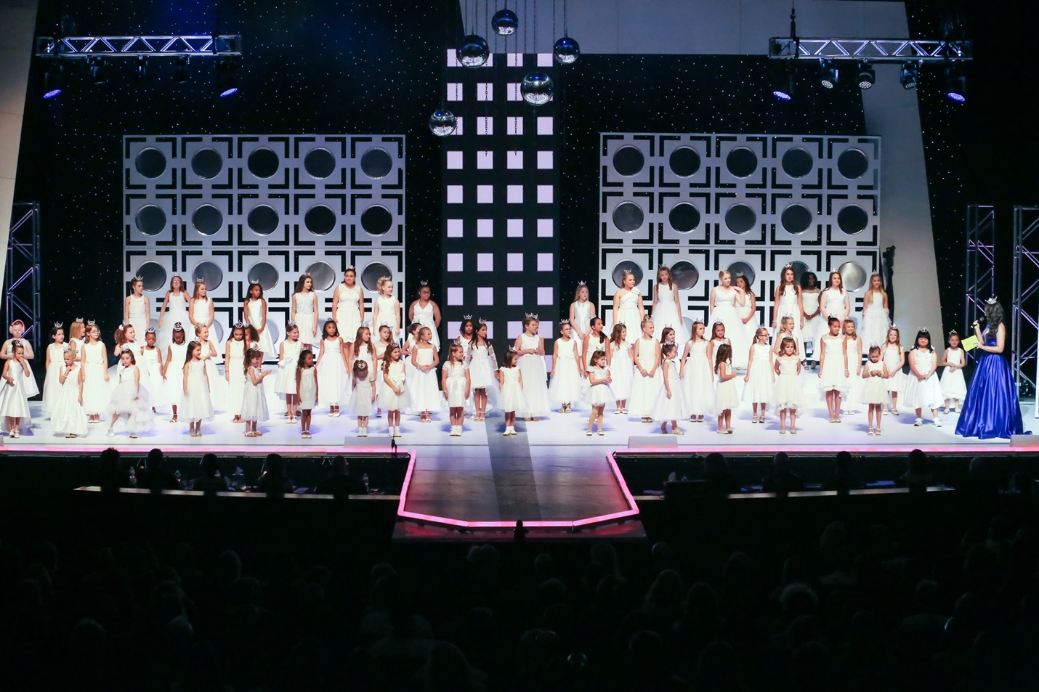

Lone Star Princess Program:
Candidates are encouraged to have a Princess, ages 5 – 12, to participate in our mentoring program. You may have more than one. Each princess will be presented on stage during preliminary competition and participate in a production number.

Our program is showcased on the Miss Texas website on its own page. For more information go to this LONE STAR PRINCESS page and find a ton of information.

