2022

COMPETITION WARDROBE

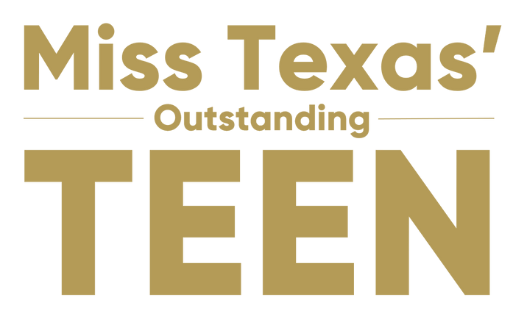

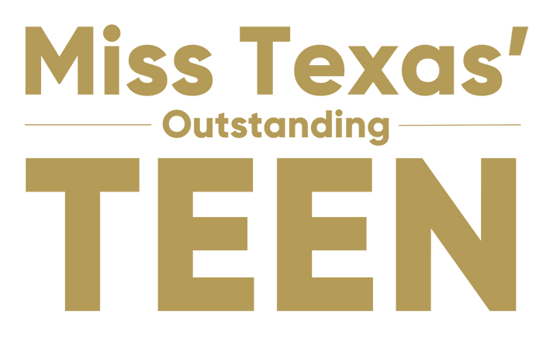
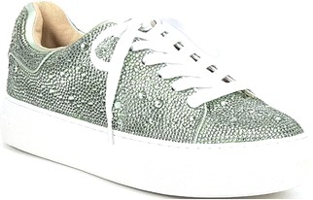

Outfit
Free People Bodysuit (Provided by Dillard's)
Spanx Vegan Leather-Like Ankle Length Skinny Pants (Provided by Dillard's)

Shoes
Rhinestone Embellished Platform Lace-Up Sneakers (Provided by Dillard's) White no-show socks (candidate provides)

Jewelry
Silver earrings only (candidate choice, candidate provides)
Earrings may be silver metal, hoop, and/or crystal/rhinestoned No AB (iridescent coated) stones
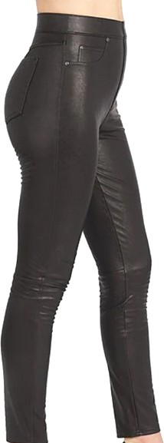
No necklaces, no bracelets

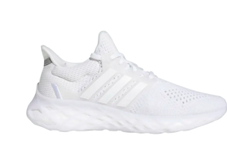
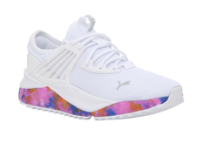
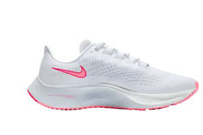

Top
Terez activewear Sports Top (Provided by Dillard's)
Selection of activewear top color will be provided on a first-come, first-served basis. See portal for information about pick-up/shipping.

Bottom
Terez activewear Leggings (Provided by Dillard's)

Jewelry/Accessories (candidate choice, candidate provides)
Simple jewelry/accessories only
Stud earrings are permitted (what you might wear during a workout) Hair accessories are permitted (keep it simple)

Shoes (candidate choice, candidate provides)
White athletic shoes - keep it simple, all brands acceptable (examples below) Color must be predominantly WHITE (color accents are acceptable)
No platforms/wedges
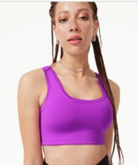
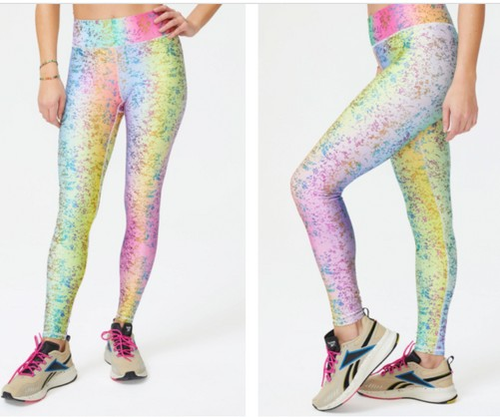
No embellishments (no rhinestones, gold studs, etc.) White no-show socks (candidate provides)

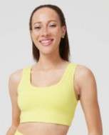

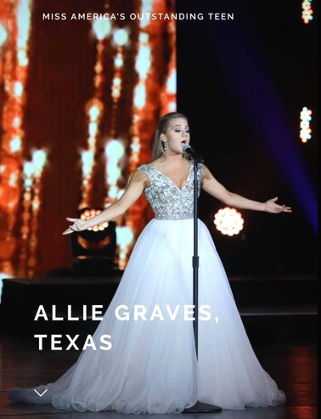

Outfit
Candidate choice (candidate provides) Age appropriate
Costume/Gown/Dress/Pants of your choice Accessorize as needed

SPECIAL NOTE: NO rosins, powders, glitter type solutions allowed in backstage areas or onstage

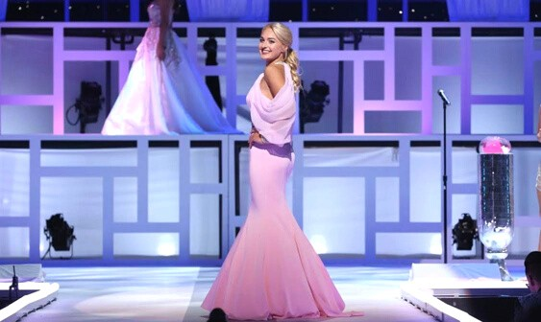

Wardrobe
Candidate choice (candidate provides)
All types of gowns/evening wear are permitted Think fashion forward but keep it TEEN!
Find a style that fits/accents your body type and reflects your age, personality and style
Ensure your selection is appropriate for stairs and can travel up AND down a staircase with ease

Shoes
4 inch maximum heel height (movement is key)
½” to 1” platform is acceptable
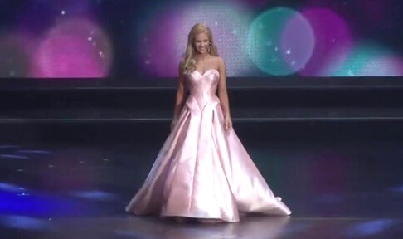
SPECIAL NOTE: NO excessive platforms which cannot be walked in

Outfit
Fashion-forward White Outfit (candidate choice, candidate provides)
Candidate may select a white outfit of their choice which best showcases their style. Candidates will wear this during Preliminary Awards and Finals Awards/Crowning (unless the candidate is in the Top 5, at which time she will be in her evening wear). The Top 5 will have their final interview in this outfit, prior to changing back into their evening wear for crowning. Returning candidates may wear the same white outfit worn
during the Closing Segment from the previous year, if desired.

Outfit Details
The outfit is determined by the candidate (following the parameters below) and the outfit could be: White dress (may be simple dress, midi dress, cocktail dress, etc.)
White skirt and top
White shorts and a top/jacket White suit (pants or shorts)
White jumpsuit, suit, jacket, or pants with a top

Parameters and Special Notes
Outfit must be white (sample ideas on next page)
Sequins, rhinestones and beading are acceptable but they must be white, silver or gold (no other colors) No trains that touch the ground, jeans, denim, or thin leggings/tights
No evening gowns (hem cannot touch the ground, no high/low) Think "After Five" and glamorous
Ensure it is well lined with appropriate undergarments (will be worn on stage under bright lights). This outfit will be reviewed by the production team during rehearsal to protect the candidates and ensure the stage lights will not create a potentially embarrassing moment for them.

Accessories
Candidate may accessorize as they see fit (candidate choice, candidate provides) Jewelry and/or belts must be silver/gold/white (no other colors - black, pink, etc.)
Accessories may be simple or rhinestoned (must be silver/gold/white and not any other color)

Shoes
Shoes may be gold, silver or nude/neutral (candidate choice, candidate provides) Keep it simple - no excessive platforms

Sample Ideas
